LAB ASSIGNMENT OF DSA

1. Given an array of integers temperatures represents the daily temperatures, return an array answer such that answer[i] is the number of days you have to wait after the ith day to get a warmer temperature. If there is no future day for which this is possible, keep answer[i] == 0 instead.

Example :
Input: temperatures = [73,74,75,71,69,72,76,73]
Output: [1,1,4,2,1,1,0,0]
Constraints:

1 <= temperatures.length <= 105
30 <= temperatures[i] <= 100

Solution:
#include <iostream>
#include <vector>
#include <stack>
using namespace std;
vector<int> dailyTemperatures(vector<int>& temperatures)
{
int n = temperatures.size();
vector<int> answer(n, 0);
stack<int> st;
for (int i = 0; i < n; i++)
{
while (!st.empty() &&
temperatures[i] > temperatures[st.top()])
{
int index = st.top();
st.pop();

answer[index] = i - index;
}
st.push(i);
}
return answer;
}
int main()
{
vector<int> temperatures = {73, 74, 75, 71, 69, 72, 76, 73};
vector<int> result = dailyTemperatures(temperatures);
cout << "Output: ";
for (int x : result)
{
cout << x << " ";
}
return 0;
} OUTPUT:
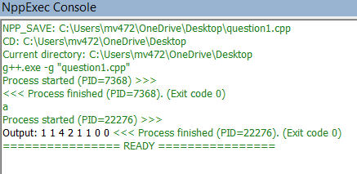

- Given head, the head of a linked list, determines if the linked list has a cycle in it. There is a cycle in a linked list if there is some node in the list that can be reached again by continuously following the next pointer. Internally, pos is used to denote the index of the node that tail's next pointer is connected to. Note that pos is not passed as a parameter.Return true if there is a cycle in the linked list. Otherwise, return false.
Solution:
#include <iostream>
using namespace std;
// Define a node
struct ListNode {
int val;
ListNode* next;
ListNode(int x) {
val = x;
next = nullptr;
}
};
// Solution class
class Solution {
public:
bool hasCycle(ListNode* head) {
ListNode* slow = head;
ListNode* fast = head;
while (fast != nullptr && fast->next != nullptr) {
slow = slow->next; // 1 step
fast = fast->next->next; // 2 steps
if (slow == fast) {
return true;
}
}
return false;
}
};
int main() {
ListNode* head = new ListNode(1);
head->next = new ListNode(2);
head->next->next = new ListNode(3);
head->next->next->next = new ListNode(4);
// Create a cycle:
// 4 points back to 3
head->next->next->next->next = head->next->next;
Solution obj;
if (obj.hasCycle(head)) {
cout << "true" << endl;
} else {
cout << "false" << endl;
}
return 0;
}

Output


- Given an integer array nums, move all 0's to the end of it while maintaining the relative order of the non-zero elements.
Note that you must do this in-place without making a copy of the array.
Example :
Input: nums = [0,1,0,3,12]
Output: [1,3,12,0,0]

Solution:
#include <iostream>
using namespace std;

class Solution {
public:
void moveZeroes(int nums[], int n) {
int j = 0;

// Move all non-zero elements to the front
for (int i = 0; i < n; i++) {
if (nums[i] != 0) {
nums[j] = nums[i];
j++;
}
}

// Fill the remaining positions with 0
while (j < n) {
nums[j] = 0;
j++;
}
}
};

int main() {
int nums[] = {0, 1, 0, 3, 12};
int n = 5;

Solution obj;
obj.moveZeroes(nums, n);

cout << "Output: [";

for (int i = 0; i < n; i++) {
cout << nums[i];

if (i < n - 1)
cout << ",";
}

cout << "]" << endl;

return 0;
} Output:
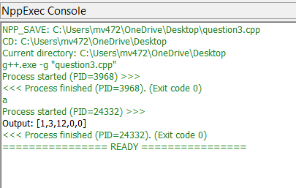

- Design a stack that supports push, pop, top, and retrieving the minimum element in constant time.
Implement the MinStack class:
MinStack() initializes the stack object.
void push(int value) pushes the element value onto the stack.
void pop() removes the element on the top of the stack.
int top() gets the top element of the stack.
int getMin() retrieves the minimum element in the stack.
You must implement a solution with O(1) time complexity for each function.
Example:
Input
["MinStack","push","push","push","getMin","pop","top","getMin"]
[[],[-2],[0],[-3],[],[],[],[]]

Output: [null,null,null,null,-3,null,0,-2]

Solution:
#include <iostream>
#include <stack>
using namespace std;

class MinStack {
private:
stack<int> st;
stack<int> minSt;

public:
// Constructor
MinStack() {
}

// Push element
void push(int value) {
st.push(value);

if (minSt.empty() || value <= minSt.top()) {
minSt.push(value);
}
}

// Remove top element
void pop() {
if (st.top() == minSt.top()) {
minSt.pop();
}

st.pop();
}

// Get top element
int top() {
return st.top();
}

// Get minimum element
int getMin() {
return minSt.top();
}
};

int main() {
MinStack obj;

obj.push(-2);
obj.push(0);
obj.push(-3);

cout << "Minimum: " << obj.getMin() << endl;

obj.pop();

cout << "Top: " << obj.top() << endl;
cout << "Minimum: " << obj.getMin() << endl;

return 0;
}
Output:

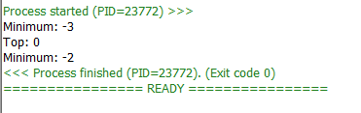

- Given a string s containing just the characters '(', ')', '{', '}', '[' and ']', determine if the input string is validAn input string is valid if:

Open brackets must be closed by the same type of brackets.
Open brackets must be closed in the correct order.
Every close bracket has a corresponding open bracket of the same type.

Solution:

#include <iostream>
#include <stack>
#include <string>
using namespace std;

class Solution {
public:
bool isValid(string s) {
stack<char> st;

for (char c : s) {

// Opening brackets
if (c == '(' || c == '{' || c == '[') {
st.push(c);
}

// Closing brackets
else {
if (st.empty()) {
return false;
}

char top = st.top();
st.pop();

if (c == ')' && top != '(')
return false;

if (c == '}' && top != '{')
return false;

if (c == ']' && top != '[')
return false;
}
}

// Stack should be empty
return st.empty();
}
};

int main() {
Solution obj;

string s = "{[()]}";

if (obj.isValid(s)) {
cout << "true" << endl;
} else {
cout << "false" << endl;
}

return 0;
}

Output:

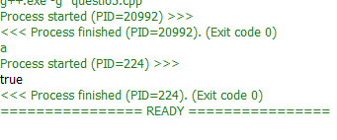

- Given the head of a singly linked list, reverse the list, and return the reversed list.

Solution:

#include <iostream>
using namespace std;

struct ListNode {
int val;
ListNode* next;

ListNode(int x) {
val = x;
next = nullptr;
}
};

class Solution {
public:

ListNode* reverseList(ListNode* head) {
ListNode* prev = nullptr;
ListNode* current = head;

while (current != nullptr) {
ListNode* next = current->next;

current->next = prev;

prev = current;
current = next;
}

return prev;
}
};

int main() {

// Create linked list: 1 -> 2 -> 3 -> 4 -> 5

ListNode* head = new ListNode(1);
head->next = new ListNode(2);
head->next->next = new ListNode(3);
head->next->next->next = new ListNode(4);
head->next->next->next->next = new ListNode(5);

Solution obj;

// Reverse the linked list
head = obj.reverseList(head);

// Print reversed list
cout << "Reversed List: ";

ListNode* temp = head;

while (temp != nullptr) {
cout << temp->val;

if (temp->next != nullptr)
cout << " -> ";

temp = temp->next;
}

cout << endl;

return 0;
}
Output:

